A PRODUCT-BASED ENGINEERING TRAINING PROGRAM WITH MULTIPLE MACHINING PROCESSES

1Yu-Yi Zhanga, 2De-Yu Wangb *, 3Jian-Xin Yangc, 4Jing Zuod

1, 2, 3, 4Tsinghua University, China

azzy360566311@tsinghua.edu.cn, bwdy@tsinghua.edu.cn, cyangjx@tsinghua.edu.cn, dzj.joe@tsinghua.edu.cn

ABSTRACT -Applying industry-level product to engineering training program opens up new possibilities for students that have different interests and backgrounds. It also provides a wide knowledge scope for skill training scheme design. This paper will discuss how to develop an engineering training program based on the process of wrist watch styling, designing, and manufacturing. The performance evaluation scheme is also customized for undergraduate students according to the product. The objective is to provide the students with a more attractive training program with dedicated targets and valuable outcomes. *Method*: We proposed and practiced a new workflow for engineering training based on the wrist watch product design and making. The students will work in teams and use various machining process ranging from high-precision milling, electric wire cutting, to laser engraving, etc. Within the process of collaboration, students will spot the engineering challenges and explore solutions. The evaluation scheme is featured with milestone tasks and corresponding discussions and assessments for students. The structure is specially designed to support collaborative learning and teamwork. Providing product-lifecycle-based evaluation will facilitate the recombination of students into cross-disciplinary teams and will promote collaboration within teams.

KEYWORDS - Project-based course; comprehensive training program; training methodology; exploratory practices

1.1 INTRODUCTION

The evolution of industry has never stopped. In recent years, as information technology transformed many aspects of industry, this fast growth is punctuated by the concept of ‘Industrie 4.0’ in Europe and ‘Manufacturing 2025’ in China. The society is ready to embrace a new trend of creation, innovation, and entrepreneurship. As for higher education, it is necessary to also transform engineering education, especially practices in engineering training. The mismatch between the training design and the industry need will lead to discrepancies between the employee capability and what the industry demands for. This study is about how a required course, engineering training, is transformed with close synchronization to innovation.

1.2 BACKGROUND

Currently, engineering training programs, or metalwork practice programs, are based on individual machining processes. The typical format is lectures about the basic principles about the machining process followed by hands-on practices. This kind of program is suitable for vocational schools, which emphasize the dexterity of the students in operating the machines. However, for undergraduate students in universities, due to the limited practice time, it is not reasonable to require the students to master any kind of machining process during the program. Furthermore, the traditional way to practice by machining a simple work piece actually confines the imagination and exploration of students. Therefore, it is necessary to develop a different kind of engineering training program. In previous cases, product-oriented program will bring up student interest. A competitive scenario for students will help increase personal involvement, enhancing the perception of knowledge.

1.3 TRAINING PROGRAM DESIGN

The training program is based on a comprehensive product development project. The students are guided to accomplish a prototype product from concept design and engineering design to manufacturing and assembly. Since the objective is to make a product, it should be of market value, stylish, desirable, and attractive. For the students, they also need to complete the manufacturing process by themselves. Consequently, they need to understand the machining processes well so as to fully utilize the capability of each kind of processes.

The program is designed based on wristwatch manufacturing. We outsource the quartz of the watch and let the students to design and make the watchcase, watchband, and watch face, and needles. During the course, students use PDM system to maintain the documents related to each step of product development. The cost of material as well as the machine time, human resources etc. are all taken into consideration by the students when they develop their products. The program is worth of three credits, lasting for three days.

1.4 PROGRAM FORMAT

The matrix management is adopted to organize the students and the instructors from different processes. They work in a product development fashion, which is enabled by a PDM system.

1. Personnel

Students are grouped into teams of nine, with two instructors assigned. One of the instructors is in charge of team building, while the other is in charge of guiding their operations. Instructors send out the project sheet. One of the nine students is assigned as team leader, while the others are divided into four functional teams.

1. Procedure

Students learn how to operate different kinds of machines at the beginning of the program. The instructors on each machining process are in charge of this part. Besides, the instructors control the progress of each step of product development. They make sure that time is reasonably allocated among various processes of CAD/CAM software tutorial, CNC milling, wire EDM, laser cutting, and 3D printing.

1. Deliverables

Each team prepares process documents under the guidance of instructors. They maintain the documents with PDM system. They also prepare a set of slides as a presentation of their design concept. The cost analysis is also included in the deliverable documents. The final product is delivered for instructors to assess. The product breakdown sheet is shown in Table 1.

**Table 1** Product functional team breakdown

|  |  |  |  |
| --- | --- | --- | --- |
| Product | Part | Process | Skill |
| Wrist watch | Watchcase | CNC milling | CAD/CAM software and precision milling |
| Watchband | Laser cutting | Pattern design and laser cutting |
| Needles | Wire EDM | EDM manufacturing |
| Quartz mount | 3D printing | 3D modeling and fast prototyping |

**Table 2** Program time schedule

|  |  |  |  |
| --- | --- | --- | --- |
| Time | | | Content |
| Day 1 | AM | 8:00-9:00 | Introduction |
| 9:15-11:30 | CAD/CAM tutorial and practice |
| PM | 1:30-3:00 | CNC milling software and machining |
| 3:15-4:30 | Wire EDM software and machining |
| Day 2 | AM | 8:00-9:00 | 3D printing and fast prototyping. Team forming |
| 9:15-11:30 | Team breakout |
| PM | 1:30-3:00 | Part designing and documenting |
| 3:15-4:30 | Manufacturing |
| Day 3 | AM | 8:00-9:00 | Manufacturing |
| 9:15-11:30 | Communication |

**Table 2** (continued) Program time schedule

|  |  |  |  |
| --- | --- | --- | --- |
| Time | | | Content |
| Day 3 | PM | 1:30-3:00 | Assembly and test |
| 3:15-4:30 | Product assessment, review, and archiving |

1.5 CASE STUDY

The wristwatch program is implemented according to the product-based design. The program include the following major steps:

1. Computer-aided-design and computer-aided-manufacturing

Students use CAD/CAM software to design the product and simulate the assembly, as shown in Fig. 1

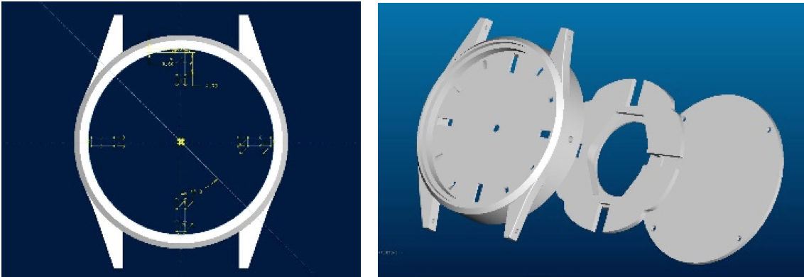

**Fig. 1** CAD/CAM software for virtual assembly

1. Defining the blank

According to the design, the dimension of the blank can be decided. The students use wire EDM technique to cut the blank needed for making the watchcase.

1. Watchcase manufacturing

Students use CNC milling to manufacture the watchcase. They follow the procedures to complete the part. 1) Import the model to SurfMill software, 2) reorient the part, 3) define the blank and proper process type, 4) define the machining parameters according to the properties of the material, 5) calculate and save the tool path, 6) simulate, verify, and refine the manufacturing process, 7) export the manufacturing process as codes, 8) transfer the codes to the machine server, 9) learn and practice how to operate the CNC milling machine, and 10) finish and inspect the part. These procedures are shown in Fig. 2.

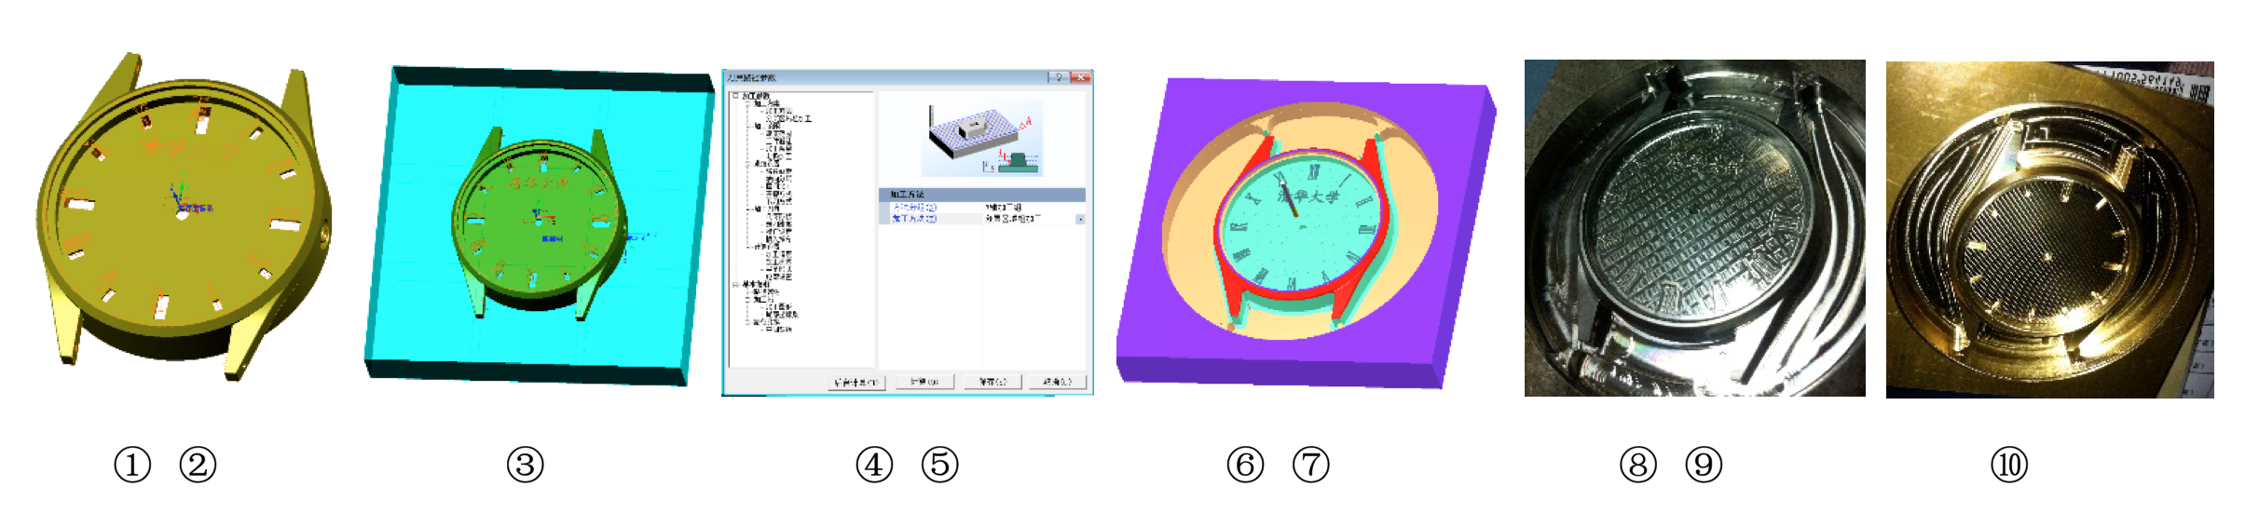

**Fig. 2** Watchcase milling process

1. Watchband manufacturing

The leather for watchbands is outsourced. Students use CorelDraw to define the pattern, scale them to the size of the leather band, and setting up the laser cutter to customize on the surface of the leather bands.

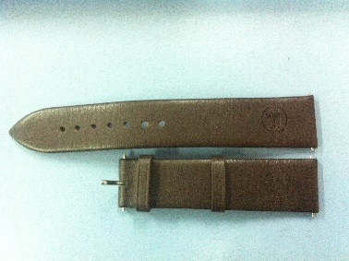

**Fig. 3** Watchband laser painting process

1. Quartz mount

Not all the parts are made of metal. The quartz support needs to be flexible so as to fit in the watchcase. Students learn how to build 3D models. Then they set up the 3D printers to build the quartz support out of ABS plastic.

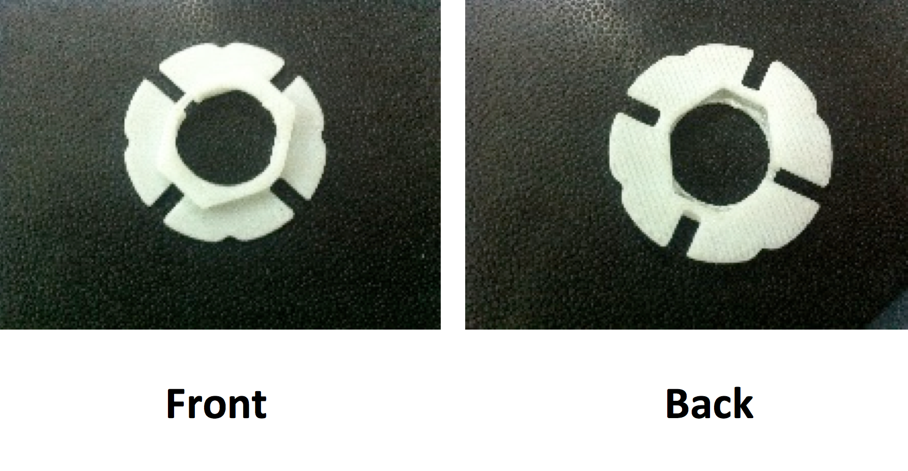

**Fig. 4** Watchband laser painting process

1. Assembly

Once all the parts are well made, the students assemble them together. Some fine adjustment is necessary when fitting the parts together.

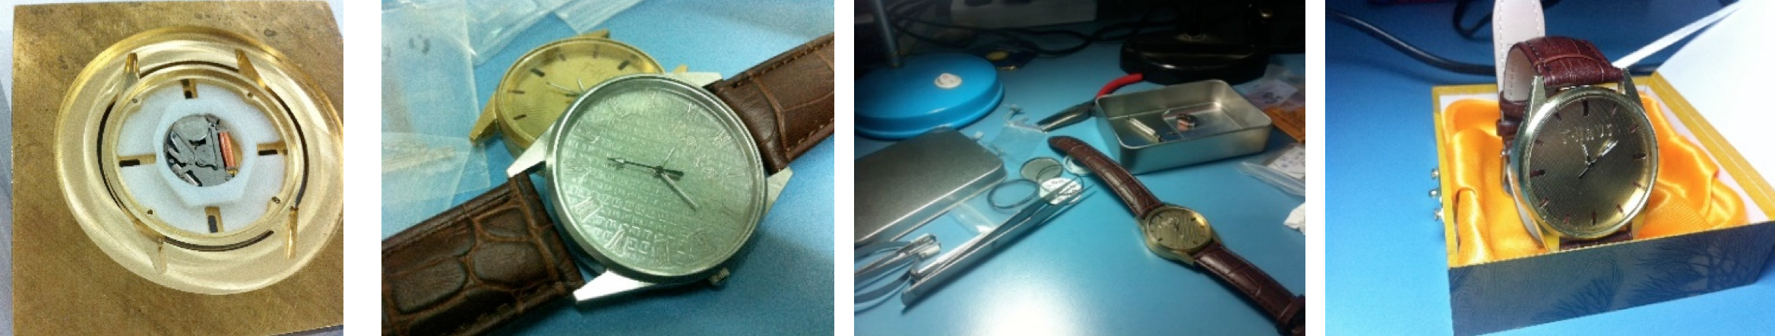

**Fig. 5** Assembly of the watch

1. Summary and review

When finished the product, the students need to submit all related document and to make a presentation about the design concept of the product. The instructors assess the products in a focus group format. The students are scored based on both their performance throughout the process and the product them made.

1.6 SUMMARY

Product-based training program is flexible. It is easily deployed with different kinds of products. The students are more evolved in a challenge-based training program than the traditional task-based program. The program described here covers a wide range of knowledge about mechanics, manufacturing, system engineering, etc. It also emphasizes the concept of a successful product on market. The students can realize their ideas within the program, thus improving their skills in a comprehensive manner.

REFERENCES

1. Editorial board (2010) Research and approach in practical engineering education. Symposium of metallurgical technologies education in Northern and Southwestern China.